Ingenico iWL220 Tableside Wireless Interface

Introduction

This interface between Five Star and Moneris uses a wireless credit and debit card processor so you can take the credit card machine to your guest’s table and process his credit or debit transaction at the table.

What the Interface Does

The interface supports both credit cards and debit cards. It allows for purchases, and refunds if Moneris allows you to do refunds. We do not suggest you support refunds in the restaurant because this is an opportunity to steal money. The wireless device supports swiped, chipped or tap transactions. We suggest that you turn off the tap feature because it does not allow for tips. Your Five Star support person will automatically turn this off for you unless you ask him not to. You can process tips, using the % or $ methods and Five Star understands the difference between the amount paid for the bill and the amount paid for the tip. You can process part payments, split payments, and multiple cards per bill. The interface does not do pre-authorisations or completions, but there is no need to in a restaurant or bar or shop.

About the Ingenico iWL220 Wireless Pinpad

The Ingenico iWL220 has a base unit which recharges the unit you take to the table with you to do your charges. The base unit will be plugged into the wall for 110 volt power, and will also require an Ethernet connection to your router or network hub. The portable unit has a printer built in to it so guest credit and debit receipts can be printed at the table. You should use one base per pinpad.

How to Get the Pinpad

You must request that Moneris supply you with Ingenico iW220 wireless pinpads configured for the Five Star Interface. Order 2 or more weeks ahead of your expected implementation date. Talk to your Moneris field sales person to get this started.

Third Party Involved TGI

There is another company and software product involved in this interface. The product is known as TGI. When the interface is running, Five Star integrates with TGI, and TGI then communicates with Moneris and the wireless credit card machine. You must order licenses from TGI. They offer three levels of licensing as shown:

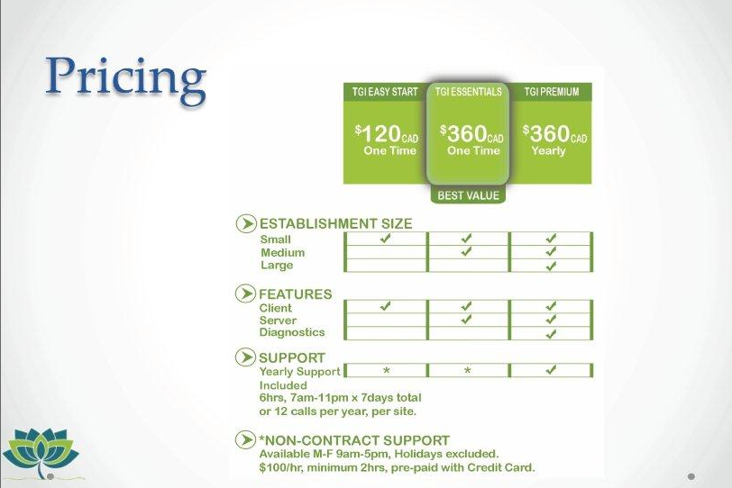

You probably don’t need a TGI support plan. Most support calls you need to make will be to Five Star and we will assist you as we always do, i.e. covered by your support plan or pay as you go support. You only need the Client feature, and not the Server or Diagnostics features.

Moneris recommends the TGI Easy Start level. They report that the TGI interface tends to require almost no support once it is installed. Five Star will provide the TGI software bundled along with our usual CD installation approach, so you don’t need to make any effort to acquire the software and we will do the setup for you. You will however have to set up a business relationship with TGI and select the pricing level you choose. At time of writing the contact information for TGI is:

Anil Jaisinghani TMC Ltd (aniljai@terminalmanagement.ca).

How you use the Pinpad with Five Star

Your routine changes a bit when you use this integration. Prior to using this integration in Five Star, when a guest pays by credit or debit, you would go to your Five Star computer, log in, select the table, get to the payments screen and select the method of payment, etc. You don’t do any of this at all with the integration. All you do is find a wireless pinpad, enter your 4 digit employee number, and select a table number. If you have multiple bills open at the table you will also have to select one of the bills. The pinpad knows the amount of the transaction. Hand the pinpad to the guest and let her do her thing. If the transaction is approved, the payment will be processed on the Five Star bill, and next time you go back to look at it the bill will have the payment already showing. The bill will have a zero balance but it will not be closed. You must touch the close button to complete the bill

There is no shift end closing to do on the machine, although you may want to set up a routine that requires servers to print a log of their transactions at the end of each shift from the printer on the pinpad.

You must, however, ensure that Moneris sets your account up with an automatic day end close that must happen some time after you close the restaurant/bar, but before your front office runs the night audit. For example, if the bar closes at 2 am and your night audit is run at 3 am, we would suggest having the night audit routine shifted to say, 4 am and have Moneris set the automatic day end close to 3 am. That you all have lots of wiggle room.

A security note – rest assured the credit card information is secure. The interface between Five Star and TGI is done over a Secure Sockets Layer. That means when card data is sent from the wireless devise to its base, it is encrypted. Also, Five Star never handles any credit or debit card information, so this interface keeps you and Five Star out of scope for PCI or PA-DSS certification. And lastly, even though no card data is shared between Five Star and TGI, there is a Secure Sockets Layer that we use to share process requests and approvals. So you are very safe!

Getting Started

When you receive your pinpads from Moneris you are ready to contact us for implementation. We will start only after you have received the pinpads. When you get them, plug the device in to the wall and start charging batteries. Make sure you buy lots of slip paper because the rolls are pretty small. Read all the documentation Moneris and Ingenico supplies you with so you understand how to use the device (charging, paper, etc).

One of the Five Star computers will be used to run the interface. This computer must be configured with a static IP address. Have your hardware person do this before we get our part started. We would suggest one of your POS terminals, so you can easily keep an eye on it or reboot if necessary. You will need to ensure that the Five Star interface and the TGI interface are running at all times for the integration to work. If either goes down, your integration is not operational and you will not be able to process credit or debit cards.

In addition, the pinpad base that plugs into the power on the wall also needs an Ethernet connection. Put this base where it will be convenient to frequently re-mount the wireless devices because they will need to be recharged during the day. The battery will not last 24 hours away from the base/charger. So you will need to have your hardware person run an Ethernet cable to that location, from your network hub or router or switch. The pinpad will function up to 200 meters from the base. If you carry it further, it will not work. For this reason, unfortunately it will likely not work for room service.

What We do to help you Get Started

When you get the software needed from Five Star to run Wireless Tableside Integration you can install it like you do any other update from us, or you can have us install it as part of the installation package we will provide you. If you are on a support plan there is no additional cost for the installation. If you are not on a support plan the installation cost is $399. The steps we will take you through are as follows:

- Install the Five Star software and the TGI software all together.
- We will guide you in changing many parameters on the Moneris pinpads. We must enable restaurant integration, we must tell the pinpad to use Ethernet integration and we must tell it the port number of the computer the Five Star and TGI integrations will be running on* (see following page for details).
- We will remove the credit and debit buttons from your payment menus in the Five Star point of sale software, and we will create a new menu that you don’t see when using POS, but that Five Star needs in order to link card types to your accounting codes.
- We will install and configure the TGI and Five Star interfaces on the computer you designate will be the interface computer.
- We will set up the new integration screens with you in Five Star. Here you will identify the port number we will use to talk to TGI (5656) and the terminal ID used to start the interface. Also you will link your existing employees’ codes to the four digit number codes the pinpad uses to identify each server. And last you will link the interface setup to the new menu we create with you for the credit and debit settlement methods.
- We will install a unique Lic.txt file that comes from TGI which validates your license to use their software. This is the license you pay for when you sign with them.

* These controls are the only controls on the pinpad that we are responsible for. These pinpads have literally hundreds of controls you can set. Moneris is your source for setting all others beyond these. They are most likely set before you receive the pinpad, but some, like handling of refunds, may need further programming.

Moneris comments in their manual as follows:

Moneris facilitates the setup of the iWL220B terminal Payment application in Standalone mode, and refers the merchant to their Restaurant POS Provider for the setup of Integrated Restaurant mode. For additional information on terminal setup and operation in Standalone mode, please refer to the following Moneris guides for the iWL220 Short-Range Mobile:
Setting up Your Terminal guide available at moneris.com/installation
Using Your Terminal guide available at moneris.com/guides

Using the interface

You must ensure that the Five Star Interface is running and that the TGI interface is running. We will put buttons for starting both in the Startup folder of the interface computer so that both will start when the computer is booted. We will also put these start buttons on your desktop so you can start them without rebooting if needed.

When it is time for the guest to pay his bill, do the following. The pinpad will always start by asking for your employee code. Each employee will have been assigned a four digit number which needs to be remembered. Enter that code and press the green OK button on the pinpad.

The pinpad may ask you for a table number if it has been programmed to do so, or it may show you a list of open tables. (If you find that scrolling thorough a long list of tables is too slow, call Five Star to reprogram so that the pinpad will just ask for a table number). The table number you select or enter must mach table numbers you have set up in Five Star.

When you have selected a table number, if there is only one bill open for the table the pinpad will display that bill and then go through various options for full or partial payment, as well as tip questions. Hand the pinpad to the guest and have her complete the process.

If there are multiple bills open for the table, scroll down to the one you will be processing and select it.

Do not hand the pinpad to the guest until you have selected the table and possibly the specific bill. Do not let the guest select the wrong one!

When the guest returns the pinpad to you the transaction will have been approved or declined. If approved, and if the payment is the full payment for the complete bill the pinpad will tell you the table is closed. The table is not closed in Five Star, but the payment will have been applied. You will be able to return to Five Star and open the table and bill for any final work such as seeing how much your tip was, and for a final close.

If the payment is a partial one, and the guest wants to use more than one card, he will have selected a partial payment or split on the pinpad, and you will need to continue to process additional cards until the bill is completely settled.

Please note that for non-credit or debit payments, like cash or room charge, you will continue to process them in Five Star as you always have done.

Please note that this integration does not use your existing integration through Moneris Eselect Plus. So there is no day end close triggered by the night audit. You must call Moneris to set up an automatic close after last f&b outlet closes, but before night audit, to ensure balancing.

You should be sure to split billing codes for debit, visa, mc etc so you have one set for Eselect Plus closes and one set for f&b. This integration does not go through Eselect Plus so the night audit balance report will not show these transactions in the first or second parts of the report, but will in the third if the billing codes are not separated.

You must set up a system in the restaurant to tell people to pay at the table. Otherwise they will walk to the front as they always have and ask any server at the front to take their payment. But with this integration you have to know who the server is, what their 4 digit number is, and what the table number is. It is much easier if the server gets to them at the table first.

