How to implement the Ingenico iWL220 Wireless Pinpad

Setup in Five Star:
- Instal a current setupweb.exe.
- Add the new Interfaces menu to the manager’s user id so he can access them.
- Configure the new screens on the POS Interfaces menu. No IP is needed if the TGI interface will be on the same machine, which it should. The port will be 5656, and you choose the terminal ID. TZ is recommended.
- Configure the Servers link on the right side of the interfaces menu. Each server must have a 4 number id like 1234, no letters. Link the new number to the servers.
- Create a new POS menu called Moneri. Make sure you know exactly which cards the hotel takes and set them all up. It will not be linked to any other menus so you don’t actually see or use this menu. It is necessary for the program to know what billing code each settlement method is linked to. You must set up the following codes if the restaurant uses them (not necessary to set up the ones they don’t use, and they must be put in the exact boxes you see here:
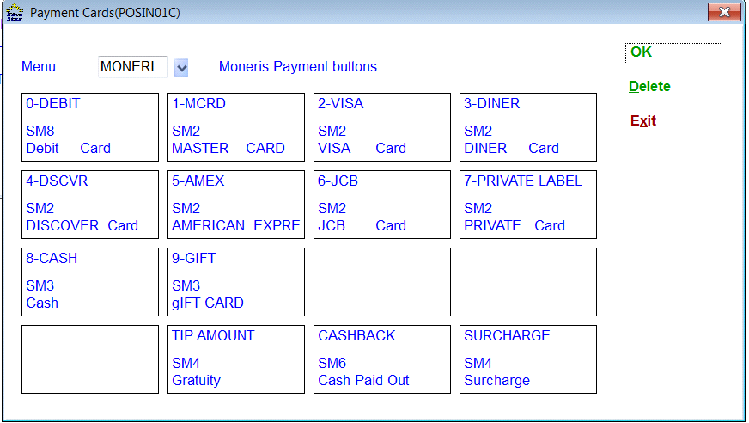

- Go back to the Interfaces setup screen and the Cards link. Select your new Moneris settlement menu.
- Remove all the credit and debit methods of payment from the settlements menus in POS Menu Setup. You might want to do this last once you have the thing up and working.

Set up the interface computer:
- Pick a computer that will be used as the interface computer. Copy a Five Star icon on to the desktop and Startup folder and rename it POS CC Interface. Change the terminal id to the one you created in step 3, i.e. TZ.
- Make a user in User Logins that will only run POS > Interfaces > Moneris Mobile Interface.
- Copy the new TGI_Client_SDK.zip and TGI_Configurator.zip files to the gjcwin folder on the interface computer and unzip them both into gjcwin on the interface computer so that the TGI_Client_8.0.58a folder is right in GJCWIN. You may need to move it after you extract it.
- Call Manu Seth at TGI 647-216-2751 and get a lic.txt file. Copy the Lic.txt file provided by TGI into the TGI_Client_8.0.58a folder. It is TGI’s way of controlling usage of their software much like our sbbwactv.
- Install Java, use the jre-7-windows-i586.exe file for 32 bit machines or the jre-7-windows-x64.exe file for 64 bit machines. Keep these files on your machines, they are about 20 mb each and we probably will not be adding them to the release cd. You can download the last two files on the list at
http://www.oracle.com/technetwork/java/javase/downloads/java-se-jre-7-download-432155.html
- Make a start button on the desktop that runs \gjcwin\TGI_Client_8.0.58a\run.bat. This is what starts the TGI side of the interface. Put this icon on the desktop and on the Startup folder. Or run it as a service:
- Download and extract all files from TGI_Suite.zip. The zip file can be found at http://www.gotgi.com/tgi/TGI_Suite.zip The password to download is tgi1.0.14
- Once the files are extracted, run ‘TGI Suite.exe’
- On the following screen, you can click on <Next> to install Java Runtime Environment and My SQL Server 5.5. In the installation that I did, these products were already installed and as a result, I simply clicked on <Finish> to move onto the next step.
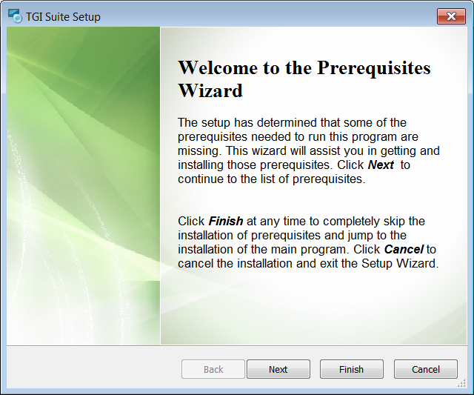

- Click on <Next> when the next installation program appears.
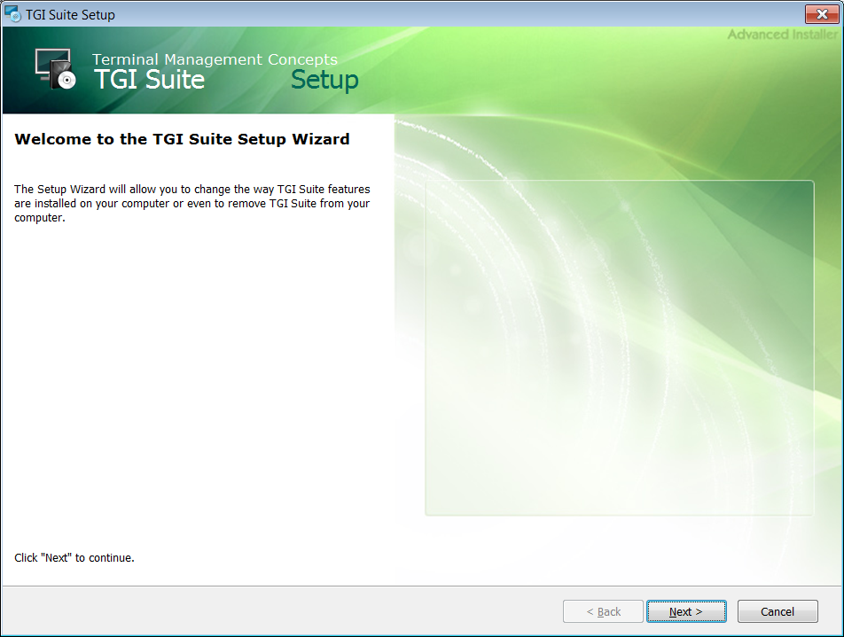

- On the next screen, select <Custom>
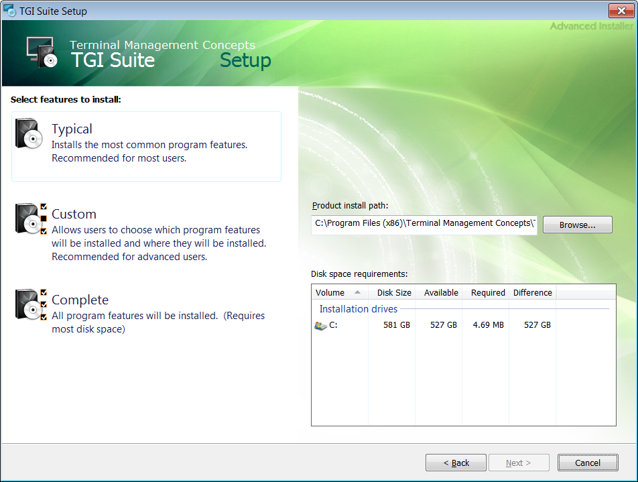

- Select “Client InstallAsService Guise” then <Next>
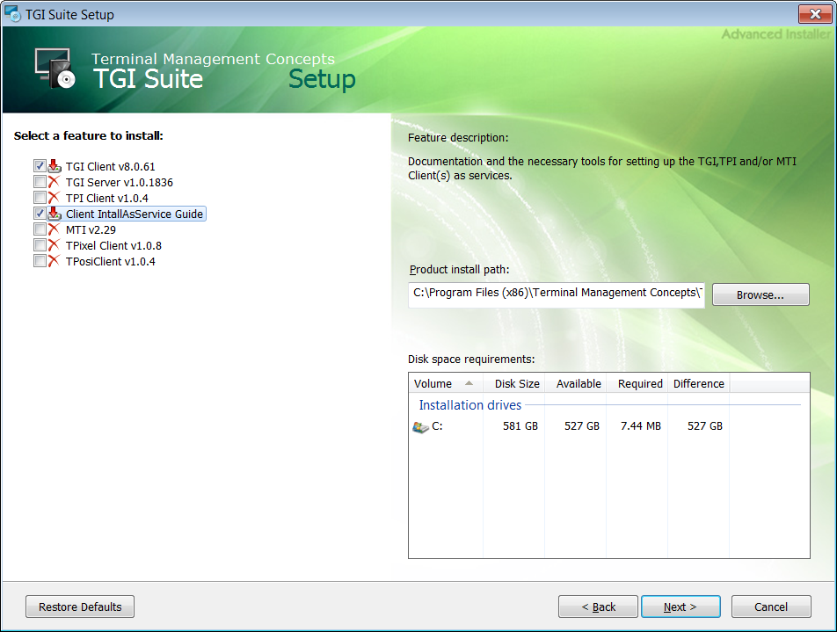

- On the following screen click on <Install>. The program will download and install a new directory into the Program Files (X86) directory called Terminal Management Concepts. In that new directory go to TGI Suite>Install_As_Service then either win32 or win 64 depending on the OS of the local computer you’re working on. I happen to be on a 64 bit machine so I navigated to win 64 and ran InstallTGIClientService64.bat. The following screen will appear.
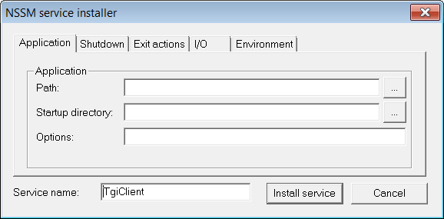
Hit the navigation button to the right of the field and find the TGI run.bat. In the Park Town example, Peter installed into the local GJCWIN\data directory. Once you’ve selected the licence file, the program will automatically fill in the “Startup directory” information. Click on <Install Service> .
- To start the service, either restart the computer or click on <Start> then <Run> and type StartTGIClientService32.bat or StartTGIClientService64.bat depending on the version of Windows.

Making Sure the Service is Running

a) Click on <Start>, Click on <Run>, type services.msc and click <OK>.

b) On the list of services you would need to find ‘TgiClient’.

c) Make sure that the service is started, if not, right click on it and start it up.

d) The Startup type should be set to Automatic, if not, right click on it, go to Properties and change the Startup type to Automatic.

Windows Vista and Windows 7
a) Click on Start

b) Type in “services.msc” in the highlighted box

Services Menu
On the list of services you would need to find ‘TgiClient’.
You need to make sure-
1) The service is Started, if not, right click on it and start it up.
2) The Startup type is set to Automatic, if not, right click on it, go to Properties and change the Startup type to Automatic.

- Check the ip address of the interface computer by clicking Start then Run then type cmd and press enter. At the dos prompt type ipconfig and press enter. The screen will tell you the ip address of the computer.
- Edit the file \gjcwin\TGI_Client_8.0.58a\conf\gateway_sm.properties using notepad as follows:
Pos.server.mode=2 (only one that should need to be changed. When set to 1 the ssl is not used and transactions can only be up to $5, when set to 2, ssl is used and no transaction limit)
tgi.server.client=0,
pos.server.ip=127.0.0.1
pos.type=4,
tgi.client.changepos=1
It says don’t modify this file at the top of the file. Go ahead and ignore that.

- Start the TGI interface and then start the Five Star interface.

Set up the Pinpad Get it plugged in and the pinpad on the base. You will need to reinitialize after this step.:
- Connect the pinpad via the network cable to the property’s local area network. It needs a lot of configuration. Press ## (ie press it twice), Admin code 17, register base, contact mode, look at the base code id on the bottom of the base and type it in. Put the pinpad back on the base and press enter.
- ## admin code 08, comms type, set to Ethernet. Press red once. It should say please wait and will test the connection. If it doesn’t tell you the connection is ok, you must reboot the pinpad by pressing yellow-# at the same time. It will reboot. Retry the step, likely it will be ok if you have an Ethernet connection that works.
- ##, admincode =08, scroll to restaurant, select type 1. Set the pinpad to table prompt ## 09 yes or no. Table prompt asks for a table number, no prompt shows a list. Ask client, probably set to No.
- ## admin code 01, enter merchant number, then phone number ( western 1888-332-8433, central 1888-699-7299, eastern 1888-358-8602), you see lots of send, receive, then you are asked to swipe the swipe the admin card. It is supplied with the new pinpad.
- Set the pinpad to know the ip address of the POS interface computer. ## admin code 18, prim host address, then enter the ip address. To get a . press 0 then #
- ##admin 08, tip entry, debit and credit, tip by $ and %.
- Call Moneris and ask them to turn off the tap feature. You cant ask for a tip if the guest uses tap, so it should be shut off.

You are done. Make sure the client reads the companion document called Ingenico iWL220 Wireless Tableside Interface.

There are three problems to be sure to alert the client to:

- No day end close, so must call Moneris to set up an automatic close after last f&b outlet closes, but before night audit, to ensure balancing.
- Should be sure to split billing codes for debit, visa, mc etc so you have one set for eselect plus closes and one set for f&b. This integration does not go thru eselect plus so the night audit balance report will not show these transactions in the first or second parts of the report, but will in the third if the billing codes are not separated.
- Must set up a system in the restaurant to tell people to pay at the table. Otherwise they walk to the front as they always have and ask any server at the front to take their payment. But with this integration you have to know who the server is, what their 4 digit number is, and what the table number is. Much easier if the server gets to them at the table first.
Set up TGI as a service:
- Download and extract all files from TGI_Suite.zip. The zip file can be found at http://www.gotgi.com/tgi/TGI_Suite.zip The password to download is tgi1.0.14
- Once the files are extracted, run ‘TGI Suite.exe’
- On the following screen, you can click on <Next> to install Java Runtime Environment and My SQL Server 5.5. In the installation that I did, these products were already installed and as a result, I simply clicked on <Finish> to move onto the next step.

- Click on <Next> when the next installation program appears.

- On the next screen, select <Custom>

- Select “Client InstallAsService Guise” then <Next>

- On the following screen click on <Install>. The program will download and install a new directory into the Program Files (X86) directory called Terminal Management Concepts. In that new directory go to TGI Suite>Install_As_Service then either win32 or win 64 depending on the OS of the local computer you’re working on. I happen to be on a 64 bit machine so I navigated to win 64 and ran InstallTGIClientService64.bat. The following screen will appear.
Hit the navigation button to the right of the field and find the TGI licence file. In the Park Town example, Peter installed into the local GJCWIN\data directory. Once you’ve selected the licence file, the program will automatically fill in the “Startup directory” information. Click on <Install Service> .
- To start the service, either restart the computer or click on <Start> then <Run> and type StartTGIClientService32.bat or StartTGIClientService64.bat depending on the version of Windows.

Making Sure the Service is Running

a) Click on <Start>, Click on <Run>, type services.msc and click <OK>.

b) On the list of services you would need to find ‘TgiClient’.

c) Make sure that the service is started, if not, right click on it and start it up.

d) The Startup type should be set to Automatic, if not, right click on it, go to Properties and change the Startup type to Automatic.

Windows Vista and Windows 7
a) Click on Start

b) Type in “services.msc” in the highlighted box

Services Menu
On the list of services you would need to find ‘TgiClient’.
You need to make sure-
1) The service is Started, if not, right click on it and start it up.
2) The Startup type is set to Automatic, if not, right click on it, go to Properties and change the Startup type to Automatic.

